
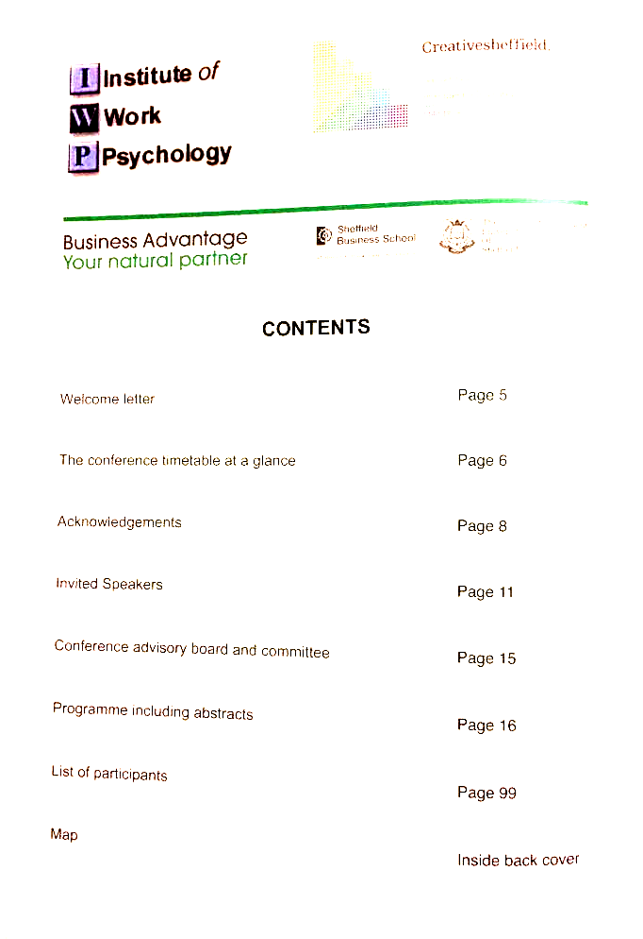

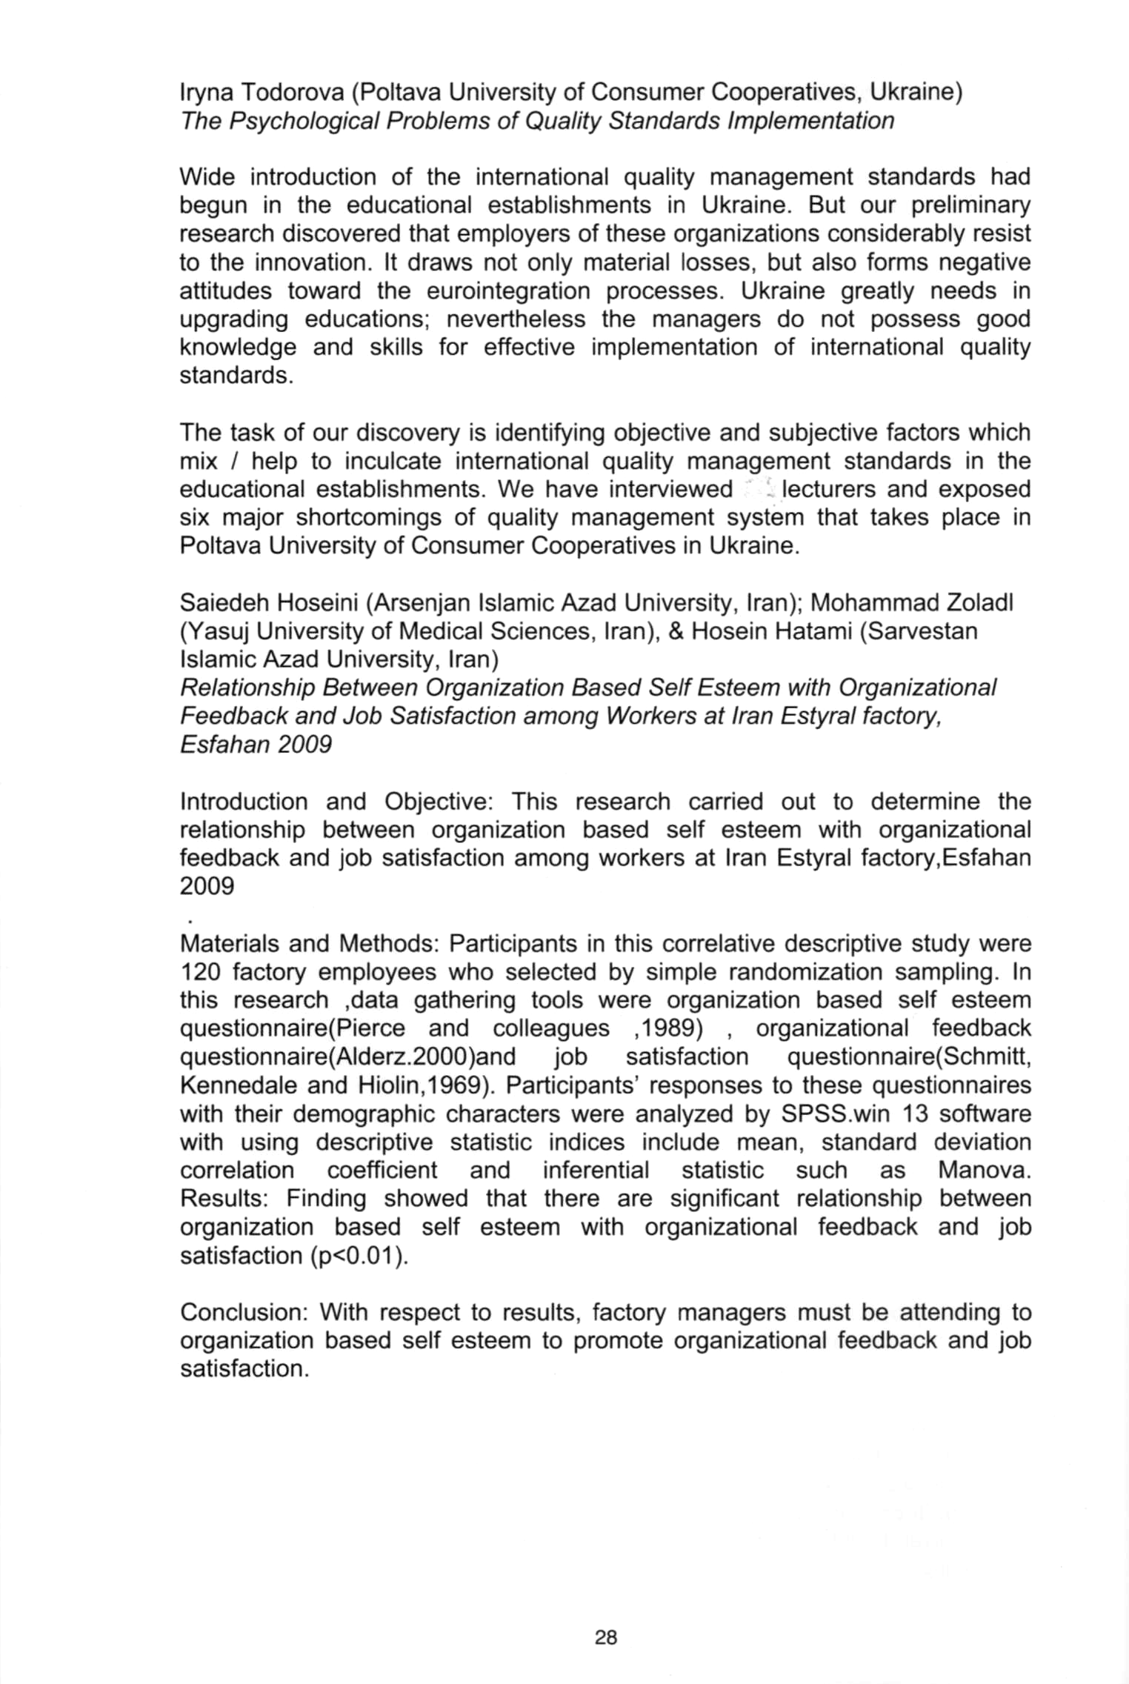

IRYNA TODOROVA
PhD, assistant professor of Poltava University Of Economics and Trade

“THE PSYCHOLOGICAL PROBLEMS OF QUALITY STANDARDS IMPLEMENTATION”

Keywords: Psychological barrier; Quality Management System; Intrapersonal Standard of Quality; Implementation; Higher Education.

Wide introduction of the international quality management standards began in the educational establishments in Ukraine. But our preliminary research discovered that employers of these organizations considerably resist to the innovation. It draws not only material losses, but also forms negative attitudes toward the eurointegration processes. Ukraine greatly needs upgrading educations; nevertheless the managers do not possess good knowledge and skills for effective implementation of international quality standards.
The task of our discovery is identifying objective and subjective factors which mix/help to inculcate international quality management standards in the educational establishments. We have exposed six major shortcomings of quality management system that takes place in in the implementation process.
First collision. Hard algorithm and regulation of the activity process is in opposition with the concept of individual style as the most effective type of working. The persons with different nature, characteristics and temperament of the nervous system need more freedom in choosing how to achieve the goal unlike a quality management system can offer them.
Second collision. Heuristic and creative nature of "man-man" work is incompatible with the requirements of the standard of previous careful planning, execution and notation the work.
Third collision. People do not want the total control over their activities; they want to feel as real subjects of work.
Fourth collision. There is a contradiction between intrapersonal standards of quality and standards that specify the quality management system. The standard was created without studying the attitudes and views of teachers. Therefore, managers and employees have different views on the quality and ways to achieve it, that distrust of the idea of quality management.
Fifth collision. The standard describes the work of unnatural machine-language. This creates semantic barrier: as usually people do not describe their own work in such way.
Sixth collision. There are doubts about the validity and reliability of the methods for quality evaluating. Assessment technology provides such methods as analysis of documents and interviews. The credibility of these methods would have been much greater in the diagnostic situation, when a person wants to get advice, consultation. The measurement adequacy decreases in a situation of audit.
A similar result was obtained in study at Malaysian universities: “A qualitative survey on seven universities in Malaysia suggests that the main reasons for people resistance are lack of knowledge and information on the quality programme, lack of motivation and complacency attitudes, and the quality programme being perceived to cause more burden rather that benefit” [1].
In Seddon's view there are several arguments against the ISO standard. It gives some background to the development of the standard, and argues that it is, at best, inappropriate and, at worst, a serious threat to organizational performance [2].
Our next task is working out the managers training program of effective implementation of quality management system to correct current system shortcomings and overcome the resistance of the staff.

References
- Noor Azman Ali. People resistance in TQM implementation: a qualitative study on Malaysian universities [Noor Azman Ali, Mohamed Zairi, Fauziah Mahat] // International Journal of Productivity and Quality Management. − Volume 3, Number 1 / 2008. − p.1 – 11.
- Seddon John. Ten arguments against ISO 9000 // Journal: Managing Service Quality / Year: 1997.- Volume: 7.- Issue: 4 .- Page: 162 – 168.

